ONLINE SUPPLEMENTAL MATERIALS
E3 ubiquitin ligase RNF128 promotes Lys63-linked polyubiquitination on SRB1 in macrophages and aggravates atherosclerosis
Yapeng Liu¹, Xinyu Zhang¹, Liwen Yu¹, Lei Cao¹, Jie Zhang¹, Qian Li¹, Xiaohong Wang¹, Wenqian Qi¹, Liangyu Cai¹, Ruiqing Ren¹, Weiwei Wang¹, Xiaobin Guo², Guohai Su², Bo Xi³, Yun Zhang^{1,2}, Chengjiang Gao^{4*}, Meng Zhang^{1,2*}, Cheng Zhang^{1,2*}
¹State Key Laboratory for Innovation and Transformation of Luobing Theory; Key Laboratory of Cardiovascular Remodeling and Function Research of MOE, NHC, CAMS and Shandong Province; Department of Cardiology, Qilu Hospital of Shandong University, Jinan, China
²Cardiovascular Disease Research Center of Shandong First Medical University，Central Hospital Affiliated to Shandong First Medical University, Jinan, China
³Department of Epidemiology, School of Public Health, Cheeloo College of Medicine, Shandong University, Jinan, China
⁴Shandong Key Laboratory of Infection and Immunity, Department of Immunology, School of Basic Medical Sciences, Shandong University, Jinan, China
, Shandong Key Laboratory of Infection and Immunity, Department of Immunology, School of Basic Medical Sciences, Shandong University, Jinan, China

Supplemental Figures and figure legends
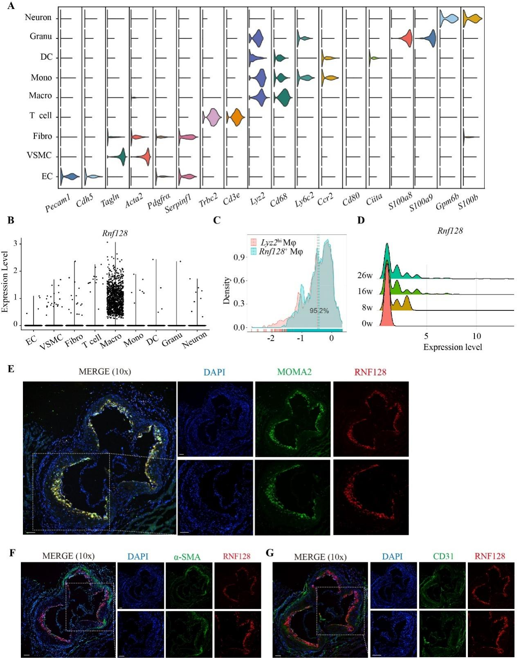
Figure S1. The mRNA and protein expression of RNF128 is specifically expressed in macrophages of the lipid core. a, Marker genes used for clustering. The 9 clusters were vascular smooth muscle cell (VSMC), T cell, granulocyte (Granu), endothelial cell (EC), fibroblast (Fibro), neuron cell, monocyte (Mono), dendritic cell (DC) and macrophage (Macro). Cells were obtained from atherosclerotic aortas of Ldlr^{-/-} mice fed WD for a series of time points (0, 8, 16, and 26 weeks). b, The expression level of Rnf128 in different types of cells. c, Rate of overlap between Rnf128 and Lyz2 was approximately 95.2%. d, The gene expression level of Rnf128 in Rnf128⁺Lyz2^{hi} macrophages (macrophages with highly expressed Rnf128 and Lyz2) from atherosclerotic aortas of mice. e, Colocalization analysis via immunofluorescence of RNF128 and MOMA-2 (specific for monocytes and macrophages) expression in atherosclerotic lesions from aortic root sections of apolipoprotein E null (ApoE^{-/-}) mice to determine the specific expression of RNF128 in macrophages. Scale bar: 100 µm. f, Colocalization analysis of RNF128 and α-SMA (α-smooth muscle actin, a marker of smooth muscle cells) expression in atherosclerotic lesions from aortic root sections of ApoE^{-/-} mice. Scale bar: 100 µm. g, Colocalization analysis of RNF128 and CD31 (a marker of endothelial cells) expression in atherosclerotic lesions from aortic root sections of ApoE^{-/-} mice. Scale bar: 100 µm.
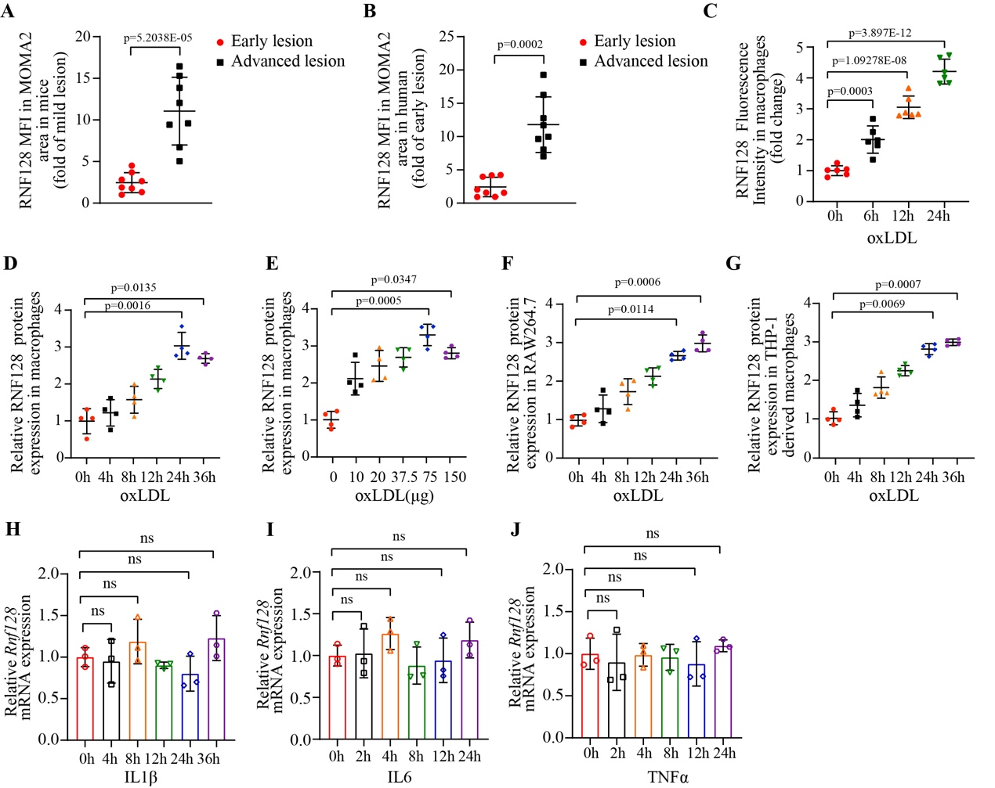
Figure S2. The RNA and protein expression of RNF128 in macrophages increases during atherosclerotic process. a, Quantification of the fluorescence intensity of RNF128 in MOMA-2 (specific for monocytes and macrophages) area in Figure 1(f) (n=8 per group, hereafter n=8). b, Quantification of the fluorescence intensity of RNF128 in MOMA-2 area in Figure 1(h). c, Quantification of the fluorescence intensity of RNF128 in Figure 1(i) (n=6). d, e, f, g, Quantitative analysis of RNF128 protein expression in Figure 1(j), 1(k), 1(l) and 1(m) (n=4). h, i, j, Quantitative PCR of RNF128 expression in macrophages treated with IL1β (20ng/mL), IL6 (20ng/mL) and TNFα (20ng/mL) for 24 hours, respectively (n=3). The “n” represents the number of biologically independent samples. Data were presented as mean ± SD, normal distribution was tested by Shapiro-Wilk method. Unpaired two-tailed Student’s t test was used for (a) and (b). One-way ANOVA followed by Dunnett post hoc test was used for (c). Kruskal-Wallis test followed by a Dunn test was used for (d) to (J). ns, not significant. Source data are provided as a Source Data file.
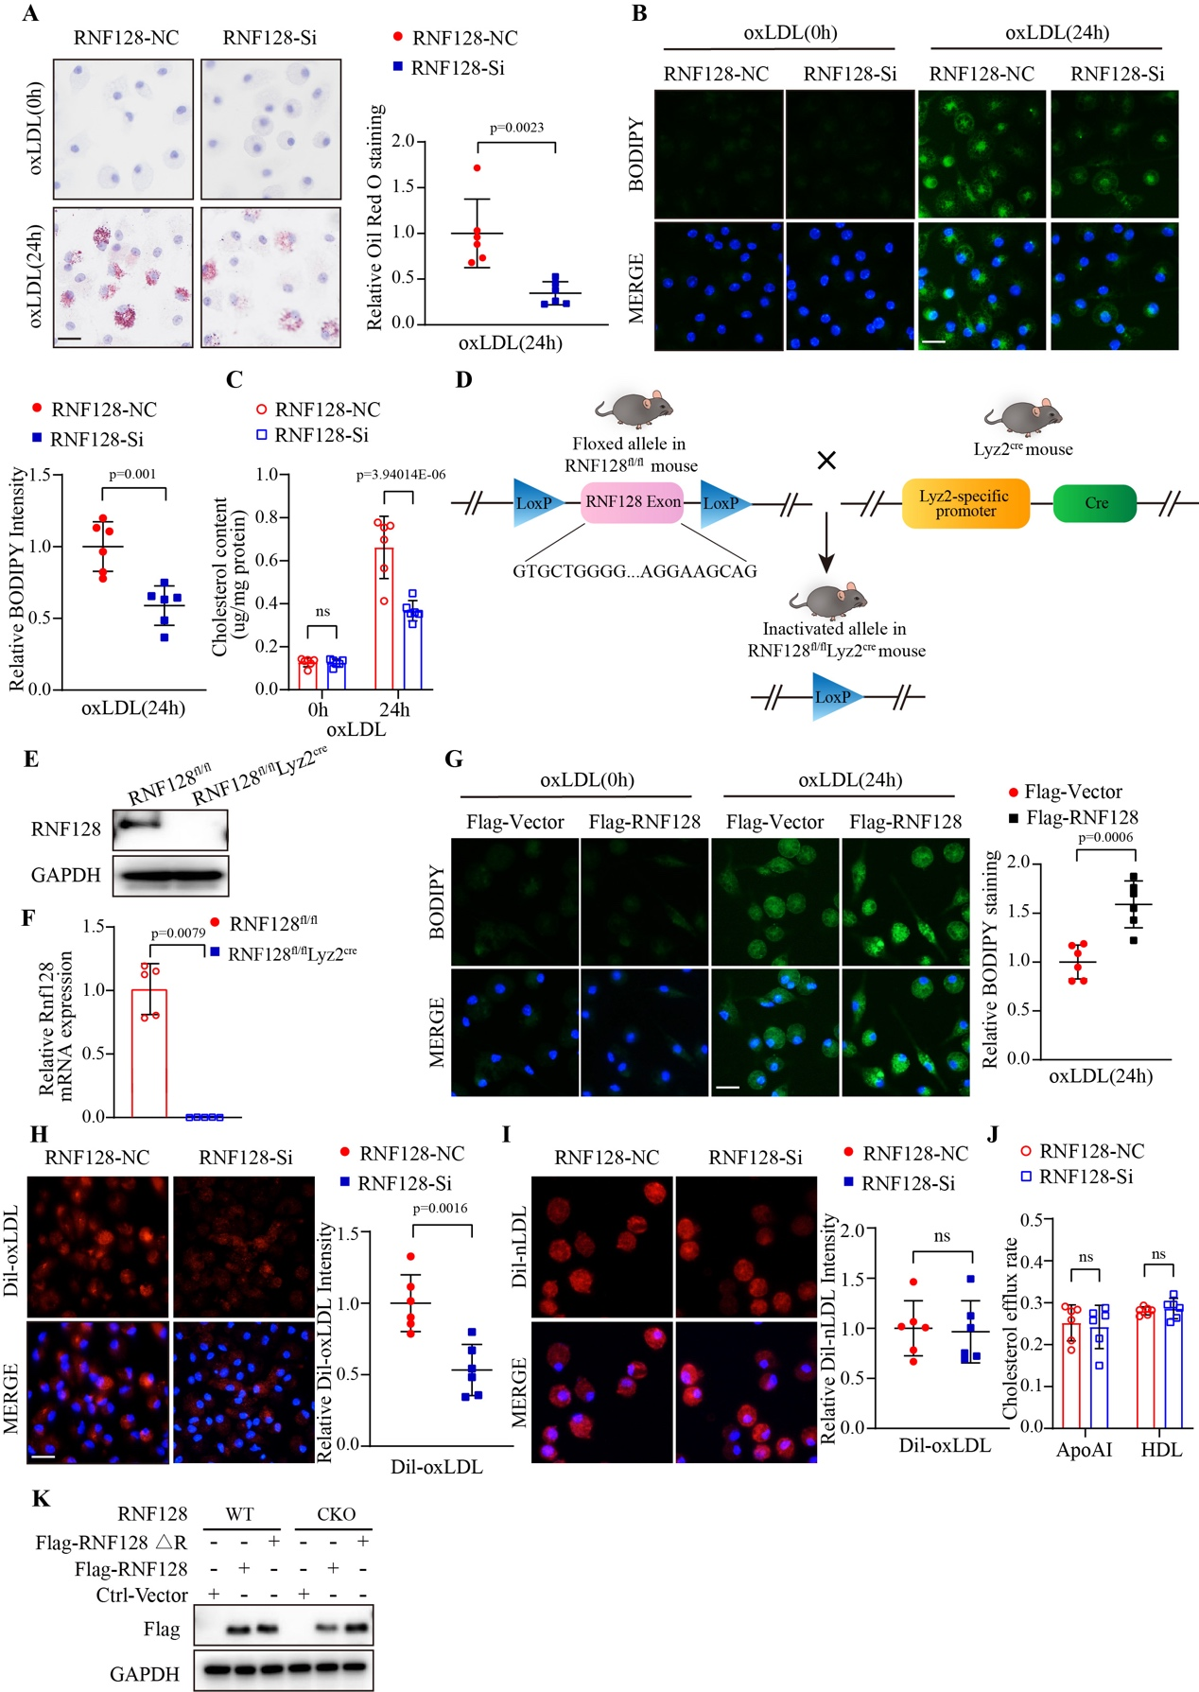
Figure S3. RNF128 deficiency alleviates foam cell formation by diminishing lipid uptake. a, Oil Red O staining of macrophages transfected with negative control (NC) or RNF128 small interfering RNA (RNF128-Si) incubated with oxidized low density lipoprotein (oxLDL) (75 µg/mL) for 24 hours (left). Quantitative analysis was shown (right, n=6). Scale bar: 20 µm. b, Neutral lipid dyed with boron-dipyrrolemethene (BODIPY) of macrophages transfected with NC or RNF128-Si in response to oxLDL. Quantitative analysis was shown (n=6). Scale bar: 20 µm. c, Total cholesterol content of macrophages transfected with NC or RNF128-Si incubated with oxLDL (n=6). d, Schematic diagram of gene-targeting protocol to generate RNF128^{fl/fl}Lyz2^{cre} mice with macrophage-specific conditional RNF128 knockout. e, Western blotting images of RNF128 in macrophages from RNF128^{fl/fl}Lyz2^{cre} mice and control mice (RNF128^{fl/fl}). f, Quantitative PCR analysis of Rnf128 from RNF128^{fl/fl}Lyz2^{cre} and RNF128^{fl/fl} mice. g, BODIPY staining in macrophages overexpressed with Flag-RNF128 or a control vector with oxLDL treatment (left). Flag-RNF128 was overexpressed using adenovirus as a gene transfer carrying C-terminal Flag-RNF128. Quantitative analysis was shown (right, n=6). Scale bar: 20 µm. h, Representative images of oxLDL labeled by red fluorescent probe (Dil-oxLDL) (20 µg/mL, 6 hours) uptake (left) and quantitative intensity analysis (right) in macrophages transfected with NC or RNF128-Si (n=6). Scale bar: 20 µm. i, Images of Dil-labeled native LDL (Dil-nLDL) (20 µg/mL, 6 hours) uptake (left) and quantitative intensity analysis (right) in macrophages transfected with NC or RNF128-Si (n=6). Scale bar: 20 µm. j, Cholesterol efflux assay of macrophages transfected with NC or RNF128-Si with Apolipoprotein A-I (ApoAI) and high-density lipoprotein (HDL) incubation, respectively (n=6). k, A catalytically inactive mutant of RNF128 lacking the RING domain was constructed based on the C-terminal Flag-RNF128 (Flag-RNF128 ∆R). Western blotting was performed to verify the protein expression in macrophages from RNF128-CKO and RNF128-WT mice with Flag-RNF128 or Flag-RNF128 ∆R overexpression. The “n” represents the number of biologically independent samples. Data were presented as mean±SD, normal distribution was tested by Shapiro-Wilk method. Mann-Whitney test was used for (c), (j) and (f). Unpaired two-tailed Student’s t test was used for the others. ns, not significant. Source data are provided as a Source Data file.
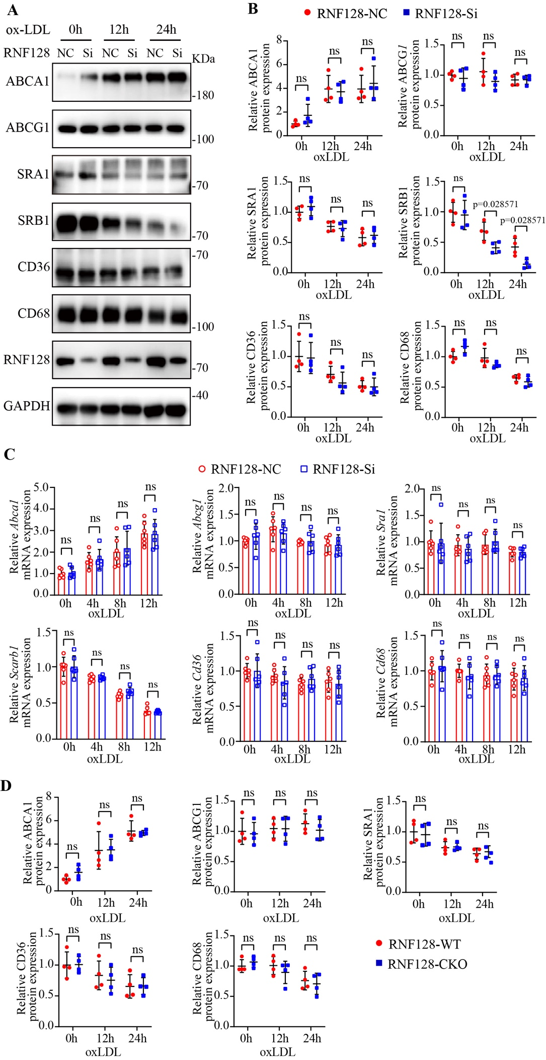
Figure S4. RNF128 deletion reduced SRB1 protein level and inflammation. a, b, Western blotting images of ABCA1, ABCG1, SRA1, SRB1, CD36 and CD68 protein levels in macrophages transfected with negative control or RNF128-Si in response to oxLDL (75 µg/mL) and its quantitative analysis (n=4). c, Quantitative PCR analysis of Abca1, Abcg1, Sra1, Scarb1 (coding for SRB1 protein), Cd36 and Cd68 in macrophages transfected with NC or RNF128-Si after oxLDL stimulation for various time points. Target gene expression was normalized to Actin mRNA level (n=6). d, Quantitative analysis of Figure 3(c) (n=4). The “n” represents the number of biologically independent samples. Data were presented as mean ± SD, normal distribution was tested by Shapiro-Wilk method. Mann-Whitney test was used for (b), (c, Relative Abca1 and Scarb1 mRNA expression), and (d). Two-way ANOVA followed by Tukey post hoc test was used for others. ns, not significant. Source data are provided as a Source Data file.
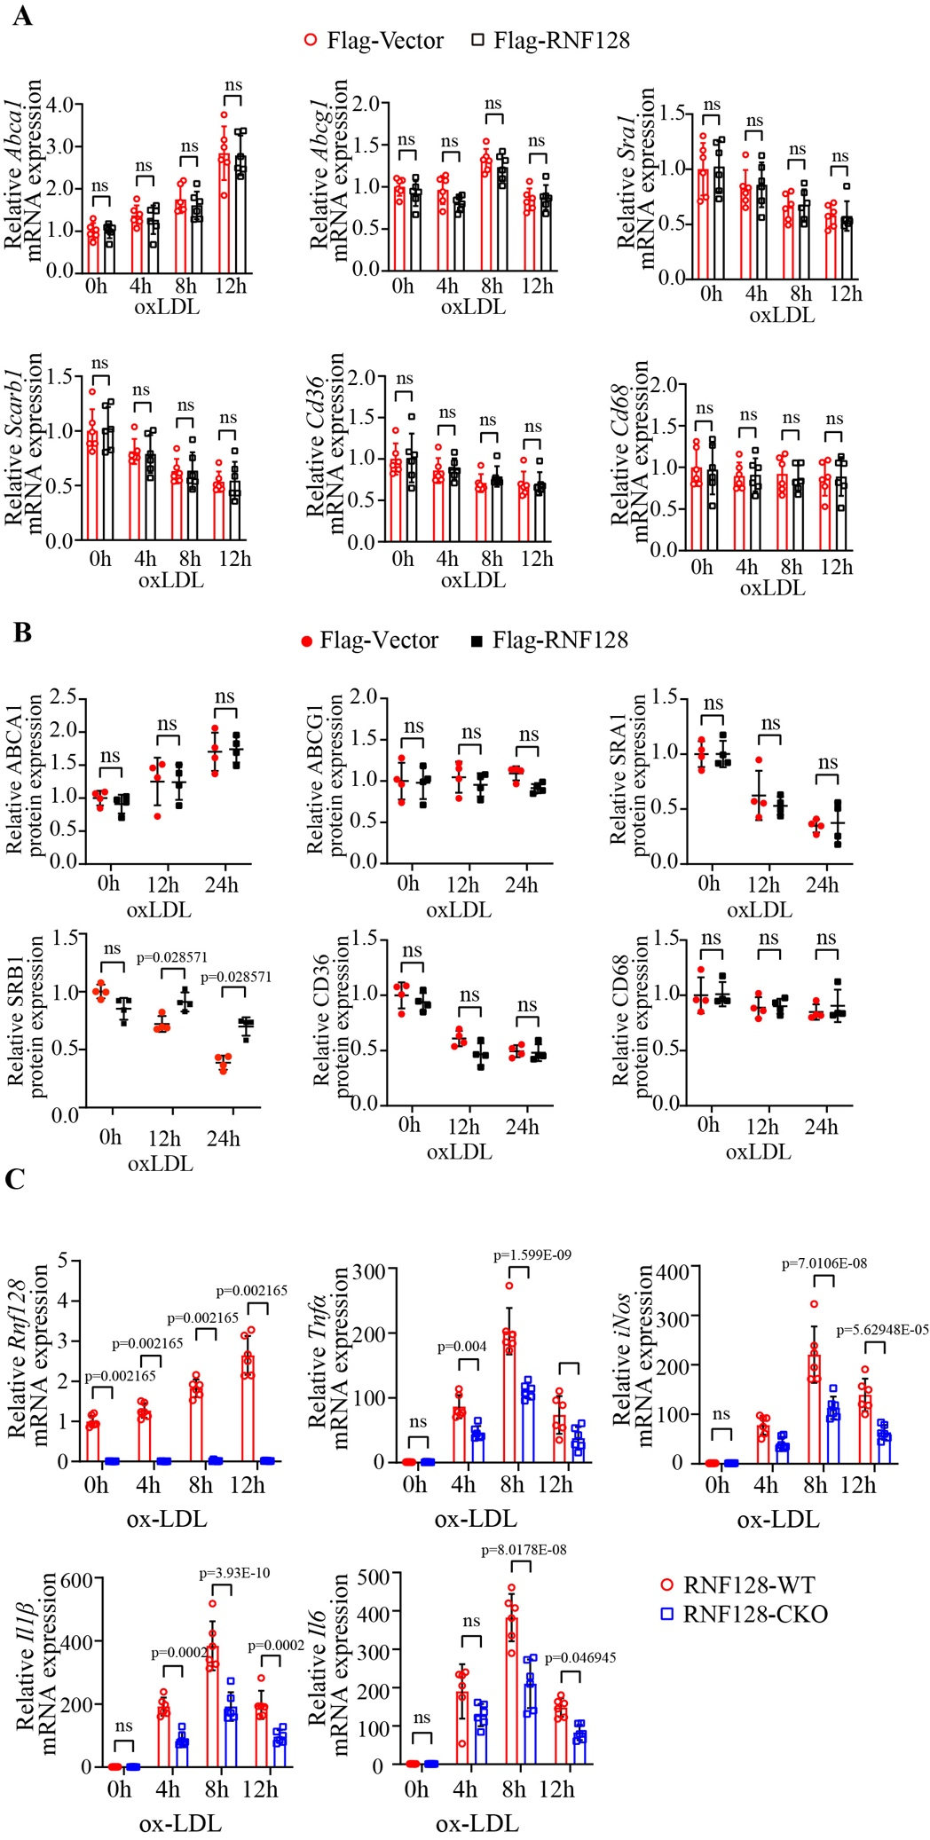
Figure S5. RNF128 overexpression upregulated SRB1 protein level.
a, Quantitative PCR analysis of macrophages with or without adenovirus-mediated RNF128 overexpression in response to oxLDL (n=6). b, Quantitative analysis of Figure 3(e) (n=4). Each experiment was repeated independently. c, Quantitative PCR analysis of Rnf128, tumor necrosis factor α (TNFα), interleukin-6 (IL6) and interleukin-1β (IL1β) genes expression in macrophages from RNF128-CKO and RNF128-WT mice after oxLDL stimulation (75 μg/mL) for various time points. Target gene expression was normalized to Actin mRNA level (n=5). The “n” represents the number of biologically independent samples. Data were presented as mean ± SD, normal distribution was tested by Shapiro-Wilk method. Mann-Whitney test was used for (b) and (c, Relative Rnf128 mRNA expression). Two-way ANOVA followed by Tukey post hoc test was used for others. ns, not significant. Source data are provided as a Source Data file.
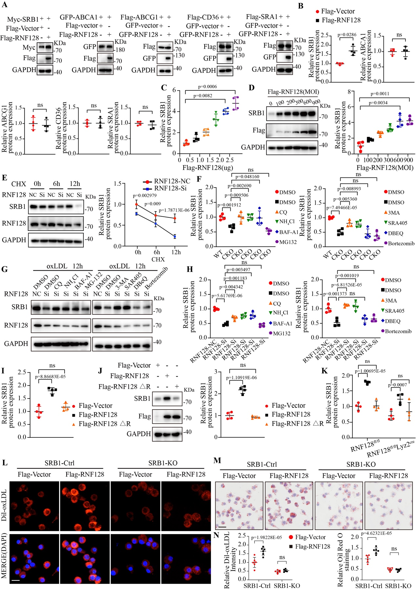
Figure S6. RNF128 stabilizes SRB1 via intervention in lysosomal degradation. a, Western blotting images of SRB1, ABCA1, ABCG1, CD36 and SRA1 proteins in HEK293T cells transfected with RNF128 or a control vector (n=4). b, Quantitative analysis of S6(a) (n=4). c, Quantitative analysis of SRB1 protein level in Figure 3(f) (n=4). d, Western blotting images of indicated proteins in macrophages overexpressed with a growing multiplicity of infection (MOI) of adenovirus carrying RNF128 (left) and its data analysis (right). After overexpression, macrophages were incubated with oxLDL for 12 hours (n=4). e, Western blotting analysis of indicated proteins in macrophages transfected with negative control or RNF128-Si. After oxLDL stimulation for 12 hours, protein synthesis was inhibited in the presence of cycloheximide (CHX, 5 µg/mL) at different time points (left). The statistical quantification was also shown (right, n=4). f, Quantitative analysis of SRB1 protein level in Figure 3(h) (n=4). g, Western blotting images of indicated proteins in macrophages transfected with NC or RNF128-Si, which were then treated with chloroquine (CQ, 5 µmol/L), ammonium chloride (NH₄Cl, 10 μmol/L), bafilomycin A1 (BAF-A1, 10 µmol/L), MG-132 (10 μmol/L), 3-MA (5 μmol/L), SAR405 (10 μmol/L), N²,N⁴-dibenzylquinazoline-2,4-diamine (DBeQ, 10 μmol/L), bortezomib (100 nmol/L) for 6 hours after oxLDL treatment for 12 hours (n=4). h, i, Quantitative analysis of Figure S4(g) and 3(i) (n=4). j, Western blotting analysis of SRB1 protein in macrophages overexpressed with the control vector and plasmids encoding wild type Flag-RNF128 or RNF128 mutant without RING domain (Flag-RNF128 ∆R) (left). Its quantitative analysis was shown (right, n=4). k, Quantitative analysis of Figure 3(j) (n=4). l, Representative images of RAW264.7 cells with or without SRB1 stable knockout and transfected with Flag-Vector or Flag-RNF128 after Dil-oxLDL treatment for 6 hours (n=6). Scale bar: 20 µm. m, Oil Red O staining of RAW264.7 cells with or without SRB1 stable knockout and transfected with Flag-Vector or Flag-RNF128 incubated with oxLDL for 24 hours (n=6). Scale bar: 20 µm. n, Data analysis of (l) and (m). The “n” represents the number of biologically independent samples. Data were presented as mean ± SD, normal distribution was tested by Shapiro-Wilk method. Two-way ANOVA followed by Tukey post hoc test was used for (n), (e) and (k). Mann-Whitney test was used for (b). Kruskal-Wallis test followed by a Dunn test was used for (c) and (d). Unpaired two-tailed Student’s t test was used for (f) and (h). One-way ANOVA followed by Dunnett post hoc test was used for (i) and (j). ns, not significant. Source data are provided as a Source Data file.
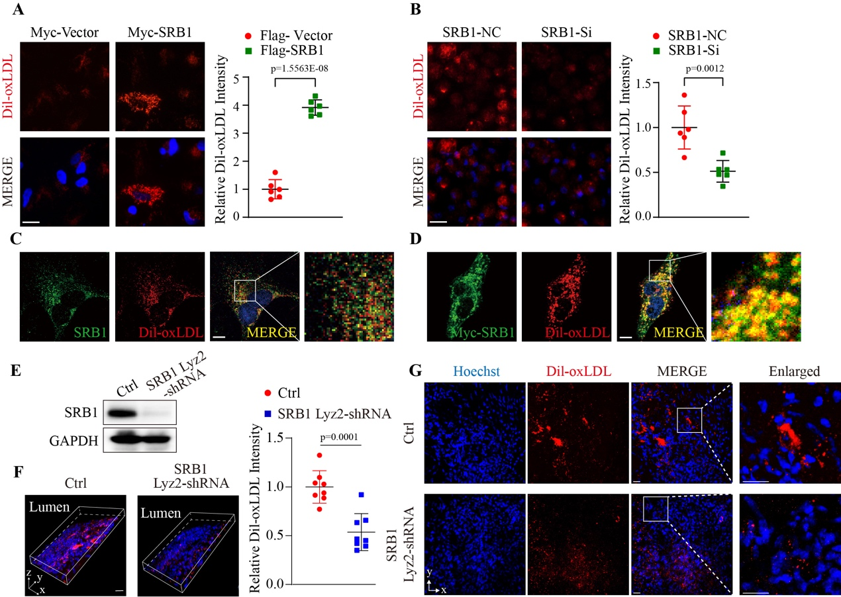
Figure S7. SRB1 exhibits a role in lipid uptake. a, Representative images of HeLa cells expressing Myc-tagged SRB1 or a control vector for 24 hours followed by Dil-oxLDL stimulation for 6 hours (left) and its quantified intensity analysis (right, n=6). Scale bar: 20 μm. b, Representative images of Dil-oxLDL uptake in macrophages transfected with negative control or SRB1-Si (left) and its quantified intensity analysis (right, n=6). Scale bar: 20 μm. c, Confocal microscopy images of Dil-oxLDL uptake in macrophages derived from wild type mice. The colocalization of endogenous SRB1 protein and Dil-oxLDL was detected (yellow area) (n=4). Scale bar: 10 μm. d, Confocal microscopy images of Dil-oxLDL uptake in Hela cells transfected with Myc-SRB1. The colocalization of SRB1 and Dil-oxLDL was detected (yellow area) (n=4). Scale bar: 10 μm. e, Western blotting images of SRB1 protein level in primary macrophages isolated from mice of the control group (Ctrl, injected with AAV-Lyz2 shRNA-control) and SRB1 Lyz2-shRNA group (injected with AAV-Lyz2 shRNA-SRB1). f, Three-dimensional depiction (left) of Dil-oxLDL localization determined by confocal fluorescence microscopy of plaques from luminal surface of the ascending aorta. Lumen was on the upper left. Similarly sized plaques were isolated from the control group and SRB1 Lyz2-shRNA group. Dil-oxLDL was shown in red and Hoechst staining of nuclei was shown in blue. Dil-oxLDL signal analysis was shown (right, n=8). Scale bar: 20 μm. g, Representative cumulative images of the x-y plane parallel to the luminal surface. Scale bar: 20 μm. The “n” represents the number of biologically independent samples. Data were presented as mean ± SD, normal distribution was tested by Shapiro-Wilk method, showing that all data were normally distributed. Unpaired two-tailed Student’s t test was used. Source data are provided as a Source Data file.
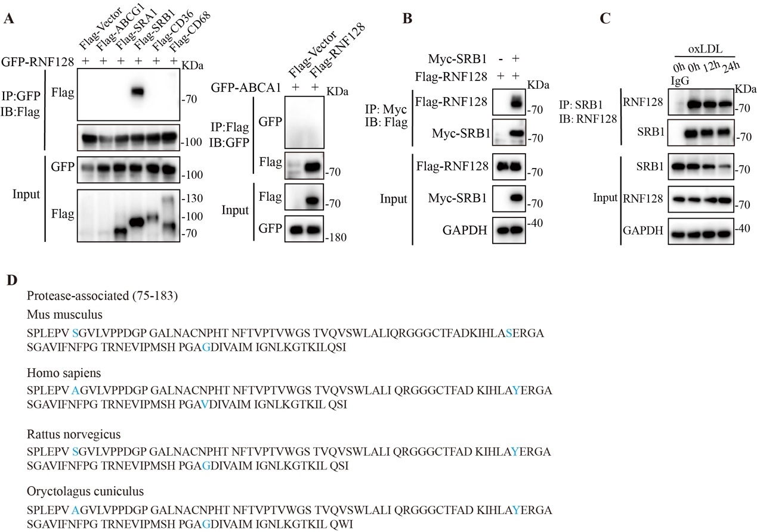
Figure S8. RNF128 interacts with SRB1 specifically. a, Co-immunoprecipitation (Co-IP) analysis of HEK293T cells co-transfected with Green fluorescent protein (GFP)-tagged RNF128 and Flag-tagged ABCG1, SRA1, SRB1, CD36, CD68 to examine the interactors of RNF128. Co-IP of whole cell lysates was performed using GFP beads (left). HEK293T cells were transfected with GFP-tagged ABCA1 as well as Flag-tagged RNF128 and Co-IP was performed using Flag beads (right). b, Co-IP assay of HEK293T cells co-transfected with Myc-SRB1 and Flag-RNF128. Co-IP was immunoprecipitated using Myc beads. c, Western blotting images of indicated proteins of endogenous Co-IP in macrophages immunoprecipitated with anti-SRB1 or rabbit IgG antibody with oxLDL stimulation for different time points. d, The sequence of protease-associated (PA) domain of RNF128 which was evolutionarily conserved among several species. Different amino acids were marked in blue. Each experiment was repeated independently with similar results for 4 times. Source data are provided as a Source Data file.
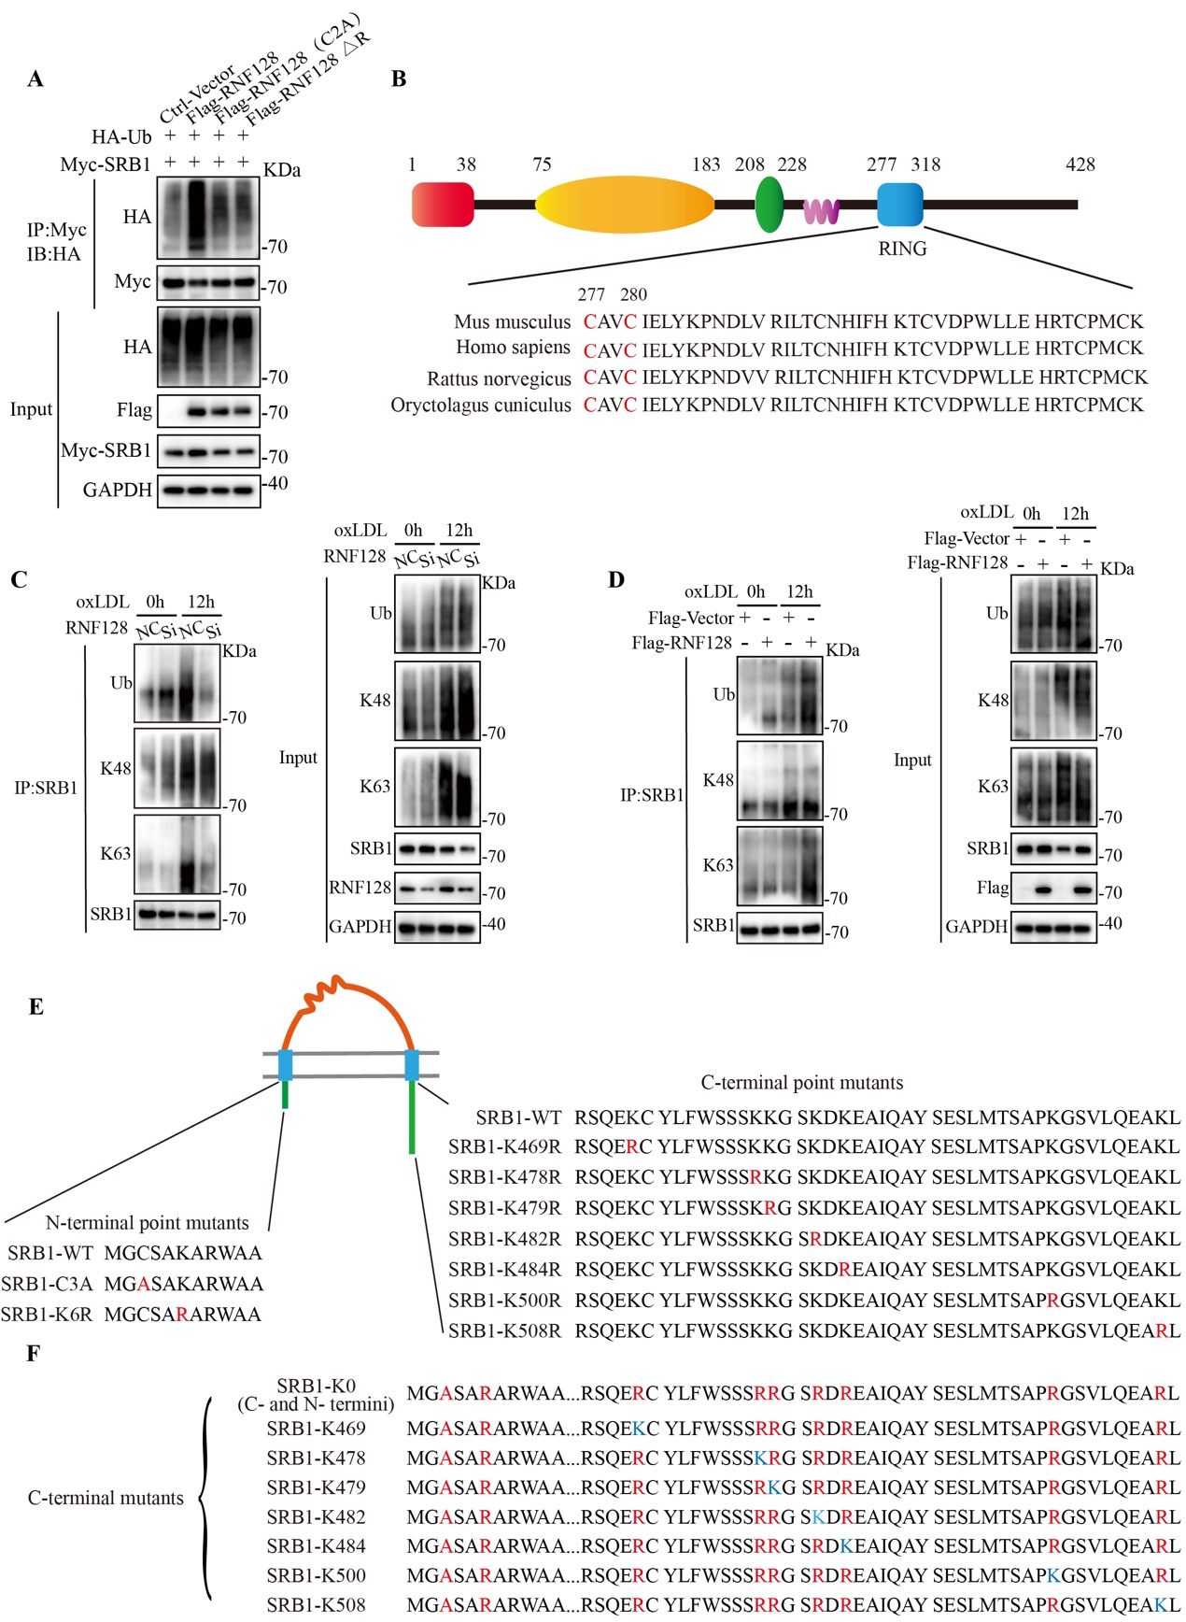
Figure S9. RNF128 promotes K63-linked polyubiquitin of SRB1. a, Co-IP analysis of SRB1 ubiquitination in HEK293T cells transfected with plasmids encoding Myc-SRB1, hemagglutinin (HA)-tagged wild type ubiquitin (Ub), as well as a control vector or plasmids encoding Flag-RNF128, Flag-RNF128 ∆R or point mutant RNF128 C2A. b, Schematic diagram of RNF128 with the sequence of RING domain. Cysteine residues at positions 277 and 280 were marked in red. c, Co-IP analysis of endogenous SRB1 ubiquitination in macrophages transfected with NC or RNF128 siRNA followed by oxLDL (75 µg/mL) stimulation. d, Co-IP analysis of endogenous SRB1 ubiquitination in macrophages overexpressed with RNF128 or control vector in response to oxLDL stimulation. e, f, Schematic diagram of mutant forms of Myc-SRB1. Mutant positions were marked in red and the single-lysine mutants reintroduced were marked in blue. Each experiment was repeated independently with similar results for 4 times. Source data are provided as a Source Data file.
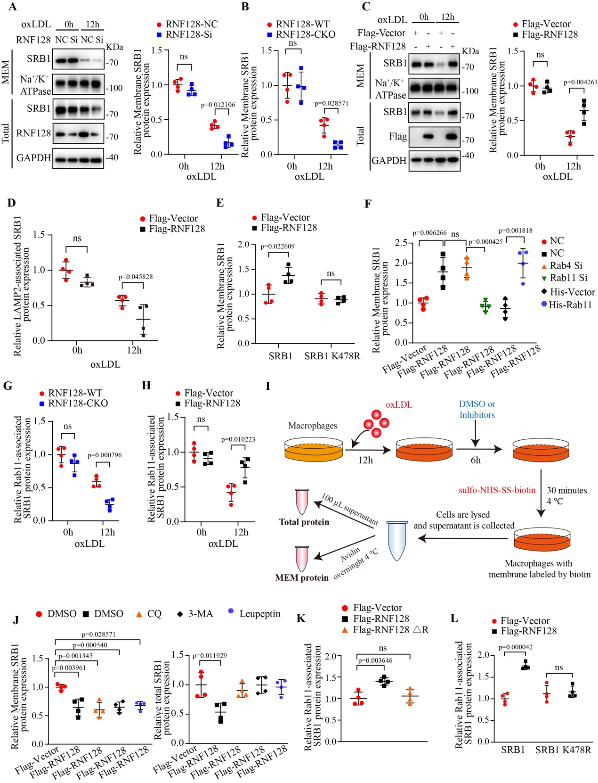
Figure S10. RNF128 promotes the translocation of SRB1 back to membrane via Rab11. a, Western blotting images of total and membrane (MEM) SRB1 in macrophages transfected with RNF128 siRNA or NC in response to oxLDL (75 µg/mL) stimulation (left) and its quantitative analysis (right). Sodium Potassium ATPase (Na⁺/K⁺ ATPase) was used as a loading control for membrane protein (n=4). b, Quantitative analysis of Western blotting in Figure 7(a) (n=4). c, Western blotting images of indicated proteins in macrophages overexpressed with RNF128 or control vector with oxLDL treatment (left) and quantitative analysis (right). Total and membrane SRB1 were detected (n=4). d, Quantitative analysis of Western blotting in Figure 6(c) (n=4). e, Quantitative analysis of Western blotting in Figure 6(d) (n=4).
f, g, Quantitative analysis of Western blotting in Figure 6(e) and 6(f) for the expression of SRB1 immunoprecipitated with anti-Rab11 antibody, respectively (n=4). h, Quantitative analysis of Western blotting in Figure 6(g) for Rab11-associated SRB1 protein level. i, A schematic of the experiment performed in Figure 6(K), revealing that biotinylation is performed after the treatment of oxLDL and inhibitors. j, Quantitative analysis of Western blotting of total (right) and membrane (left) proteins in macrophages incubated with DMSO, CQ, 3-MA or leupeptin after oxLDL stimulation (n=4). k, l, Quantitative analysis of Western blotting in Figure 6(l) and 6(m) for the expression of SRB1 immunoprecipitated with anti-Rab11 antibody, respectively (n=4). The “n” represents the number of biologically independent samples. Data were presented as mean±SD. Mann-Whitney test was used for (j, Leupeptin). Unpaired two-tailed Student’s t test was used for others. ns, not significant. Source data are provided as a Source Data file.
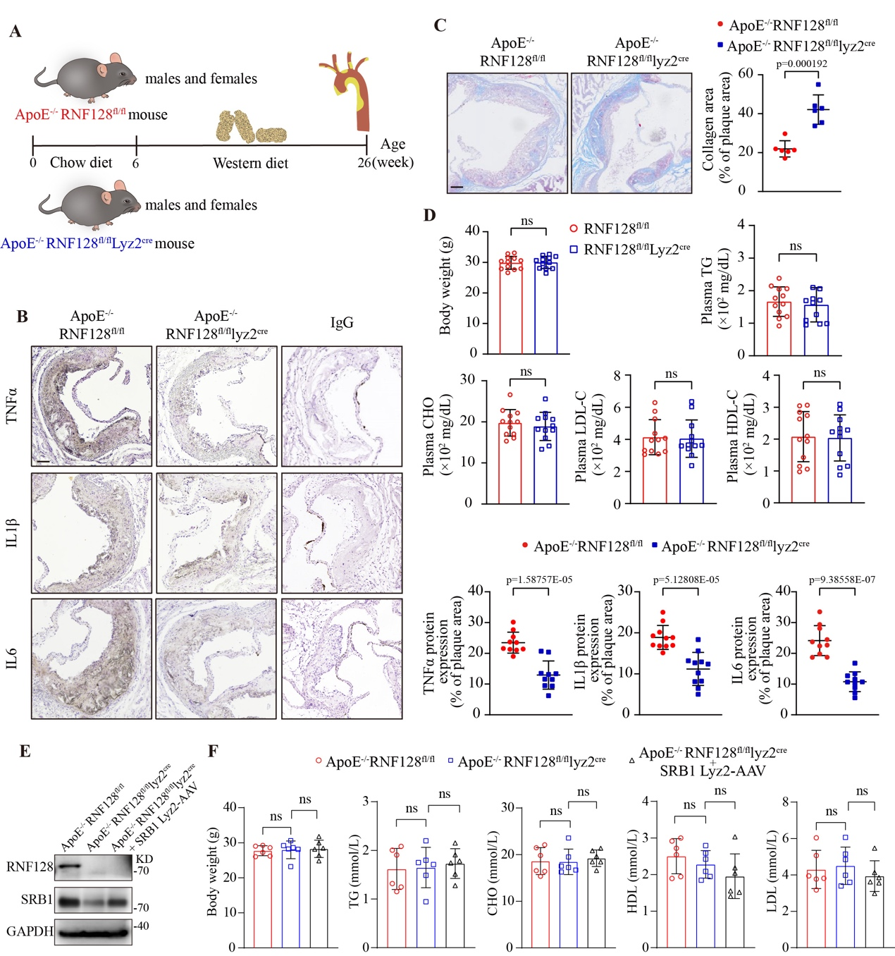
Figure S11. RNF128 deficiency reduced inflammatory cytokines within plaques. a, Schematic diagram of the protocol for atherosclerotic model building. b, Immunohistochemistry staining of TNFα, IL1β, IL6 and IgG (negative control) within plaques in aortic root plaques (left) and quantitative analysis (right, n=10). Scale bar: 100 µm. c, Masson’s Trichrome staining of aortic root sections. Data analysis was shown (n=6). Scale bar: 100 µm. d, Body weight, plasma levels of triglyceride (TG), total cholesterol (CHO), low density lipoprotein cholesterol (LDL-C) and high density lipoprotein cholesterol (HDL-C) were measured (n=12). e, Western blotting images of RNF128 and SRB1 protein levels in primary peritoneal macrophages isolated from mice of three indicated groups. f, Body weight, plasma levels of TG, CHO, LDL-C and HDL-C were measured (n=6). The “n” represents the number of biologically independent samples. Data were presented as mean ± SD. Normal distribution was tested by Shapiro-Wilk method. One-way ANOVA followed by Dunnett post hoc test was used for (f). Unpaired two-tailed Student’s t test was used for others. ns, not significant. Source data are provided as a Source Data file.
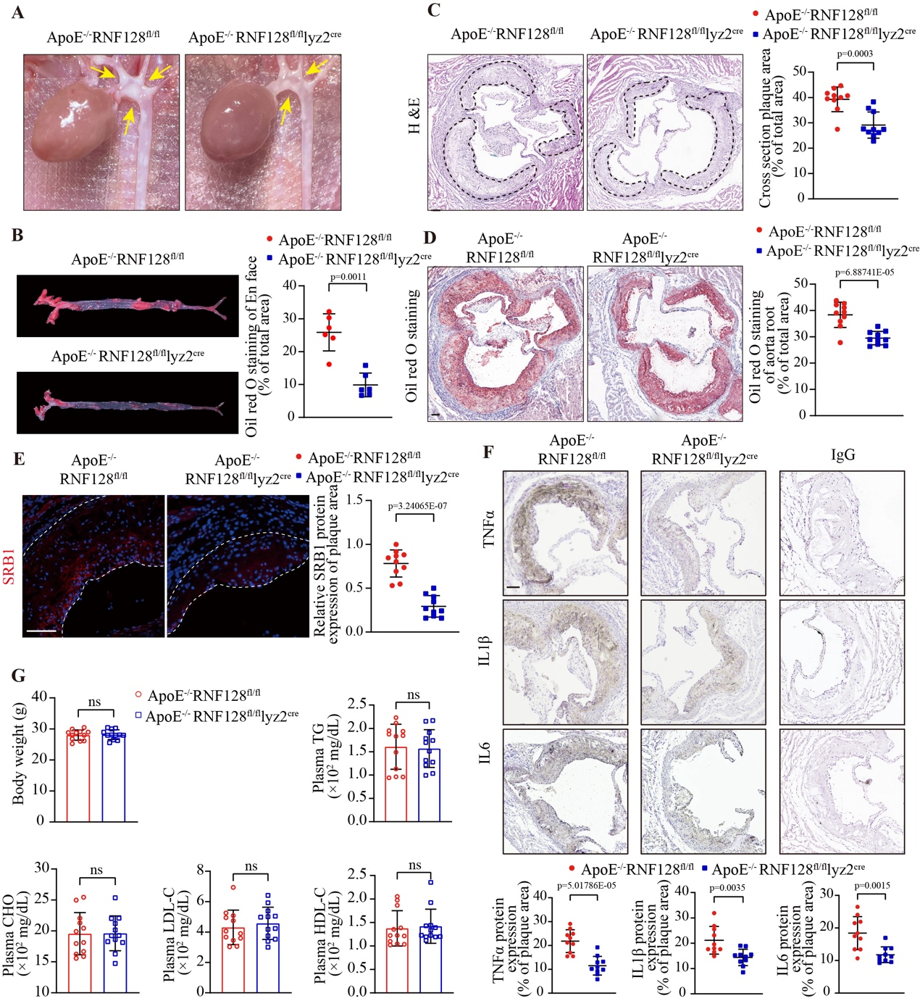
Figure S12. RNF128 deficiency in macrophages protects from atherogenesis in ApoE^{-/-} mice (females). a, Representative in situ images of aortic arch with atherosclerotic plaques (yellow arrows) from ApoE^{-/-}RNF128^{fl/fl}Lyz2^{cre} mice and ApoE^{-/-}RNF128^{fl/fl} mice fed a Western diet for 20 weeks (n=12). b, En face Oil red O staining of whole aortas (left) and data analysis (right). Plaque area was quantified as percentage of lesion area/total surface area of aorta (n=6). c, Hematoxylin-eosin (H&E) staining of cross sections at the aortic root (left) and data analysis (right). Atherosclerotic plaques were demarcated by black dashed lines (n=10). Scale bar: 100 μm. d, Oil red O staining of aortic root sections (left) and data analysis (right). Lesion size was quantified as percentage of lesion area/lumen area (n=10). Scale bar: 100 μm. e, SRB1 protein identified by immunofluorescent staining in aortic root lesions (left) and data analysis (right). Atherosclerotic plaques were demarcated by white dashed lines (n=10). Scale bar: 100 μm. f, Immunohistochemistry (IHC) staining of TNFα, IL1β, IL6 and IgG (negative control) within plaques in aortic root plaques and quantitative analysis (n=10). Scale bar: 100 μm. g, Body weight, plasma levels of triglyceride (TG), total cholesterol (CHO), low density lipoprotein cholesterol (LDL-C) and high density lipoprotein cholesterol (HDL-C) were measured (n=12). The “n” represents the number of biologically independent samples. Data were presented as mean ± SD, normal distribution was tested by Shapiro-Wilk method, showing that all data were normally distributed. Unpaired two-tailed Student’s t test was used for others. ns, not significant. Source data are provided as a Source Data file.
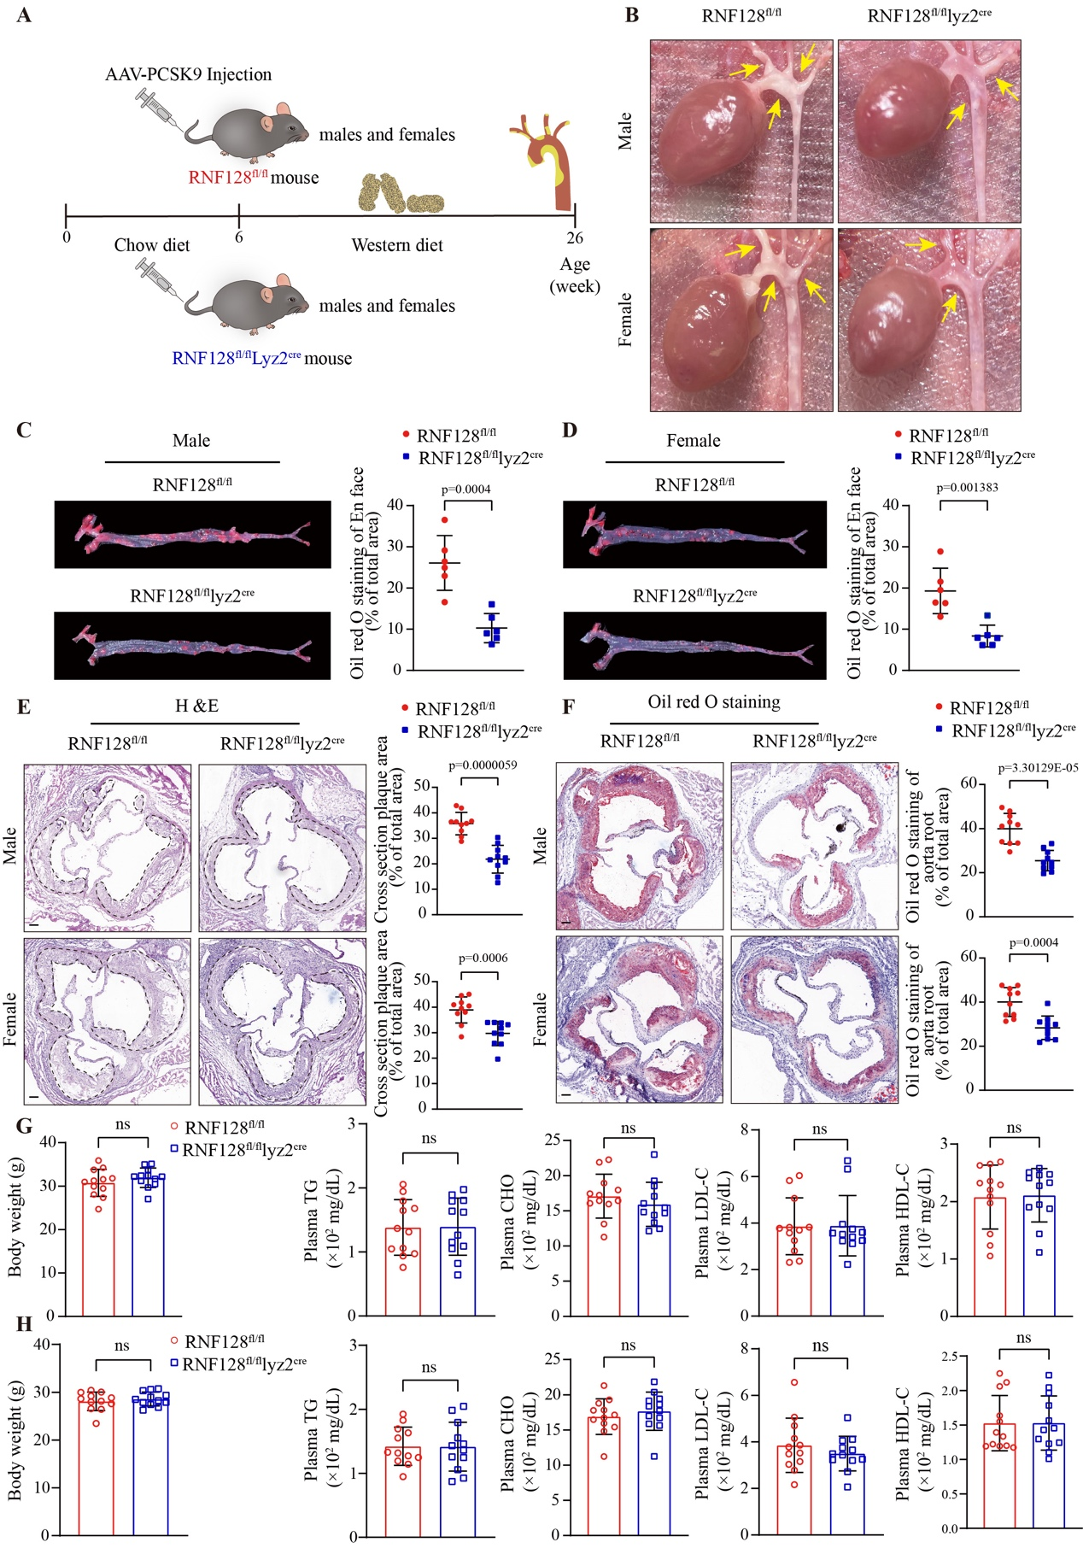
Figure S13. Macrophage-RNF128 silence exerts an anti-atherosclerotic role in LDLR-deficiency mice (males and females). a, Schematic diagram of the protocol for LDLR-deficiency atherosclerotic model via AAV-PCSK9 intravenous injection in RNF128^{fl/fl}Lyz2^{cre} mice and RNF128^{fl/fl} mice. b, Representative photographic images of aortic arch with atherosclerotic plaques (yellow arrows) from RNF128^{fl/fl}Lyz2^{cre} mice and RNF128^{fl/fl} mice fed a Western diet for 20 weeks (n=12). c, d, En face Oil red O staining of whole aortas (left) with its data analysis (right) of males and females, respectively. Plaque area was quantified as percentage of lesion area/total surface area of aorta (n=6). e, H&E staining of cross sections at the aortic root (left) with data analysis (right). Atherosclerotic plaques were demarcated by black dashed lines (n=10). Scale bar: 100 μm. f, Oil red O staining of aortic root sections (left) and data analysis (right). Lesion size was quantified as percentage of lesion area/lumen area (n=10). Scale bar: 100 μm. g, h, Body weight, plasma levels of TG, CHO, LDL-C and HDL-C of males and females were measured, respectively (n=12). The “n” represents the number of biologically independent samples. Data were presented as mean ± SD, normal distribution was tested by Shapiro-Wilk method, showing that all data were normally distributed. Unpaired two-tailed Student’s t test was used. ns, not significant. Source data are provided as a Source Data file.

Tables
TableS1. Baseline characteristics of the human specimens
 | No. | Age (years) | Sex | Body weight (Kg) | Blood lipids (mmol/L)
 |  |  |  |  | LDL-C | HDL-C | TG | CHO
Early lesions | 1 | 64 | Male | 65 | 0.45 | 0.56 | 0.49 | 1.21
Early lesions | 2 | 51 | Male | 72 | 3.5 | 0.7 | 2.15 | 4.9
Early lesions | 3 | 64 | Male | 62 | 2.21 | 0.43 | 1.79 | 3
Early lesions | 4 | 49 | Male | 65 | 1.84 | 0.79 | 0.88 | 3.05
Early lesions | 5 | 23 | Male | 70 | 2.07 | 1.05 | 0.62 | 3.53
Early lesions | 6 | 65 | Female | 60 | 1.61 | 0.54 | 1.14 | 2.5
Advanced lesions | 1 | 66 | Male | 63 | 3.49 | 0.73 | 2.91 | 5.75
Advanced lesions | 2 | 57 | Male | 71 | 0.95 | 1.51 | 3.69 | 4.36
Advanced lesions | 3 | 38 | Male | 45 | 2.76 | 0.67 | 1.12 | 4.05
Advanced lesions | 4 | 64 | Female | 75 | 2.93 | 0.65 | 2.22 | 4.65
Advanced lesions | 5 | 44 | Male | 65 | 2.37 | 0.52 | 1.53 | 3.46
Advanced lesions | 6 | 40 | Male | 80 | 2.53 | 0.61 | 0.81 | 3.3

TableS2. Primer sequence for mouse genotyping
Primer name | Sequence
JS06086-Rnf128-3wt-tF1 | TGACTGACT TATGCAAAGGTTAG
JS06086-Rnf128-3wt-tR1 | CTAAATGTGCAATGTGGCTTGTG
Lyz2-iCre-tF1 | AGTGCTGAAGTCCATAGATCGG
Lyz2-iCre-tR1 | CTGATTCTCCTCATCACCAGG
Lyz2-iCre-tF2 | AGTGCTGAAGTCCATAGATCGG
Lyz2-iCre-tR2 | GTCACTCACTGCTCCCCTGT
ApoE-F1 | TGCCTAGTCTCGGCTCTGAACTAC
ApoE-R1 | CAACCTGGGCTACACACTAATTGAG

TableS3. Antibodies and manufacturers
Target antigen | Company | Catalog No. | Working Concentration
MOMA2 | Abcam | ab33451 | IF: 1:100
Normal  rabbit IgG | Cell Signaling Technology | 2729S
GAPDH | Cell Signaling Technology | 2118S | Western blotting: 1:1000
α-SMA | Abcam | ab7817 | IF: 1:50
CD31 | Abcam | ab222783 | IF: 1:50
ABCA1 | Cell Signaling Technology | 96292S | Western blotting: 1:1000
ABCG1 | Abcam | ab52617 | Western blotting: 1:1000
SRA1 | Abcam | ab151707 | Western blotting: 1:1000
SRB1 | Abcam | ab217318 | Western blotting: 1:1000  IF: 1:50
CD36 | Abcam | ab133625 | Western blotting: 1:1000
CD68 | Abcam | ab125212 | Western blotting: 1:1000
Myc | Cell Signaling Technology | 2278S | Western blotting: 1:1000  IF: 1:50
Flag | Sigma-Aldrich | F1804 | Western blotting: 1:1000
GFP | Cell Signaling Technology | 2956S | Western blotting: 1:1000
GST | Cell Signaling Technology | 2624S | Western blotting: 1:1000
HA | ORIGENE | TA180128 | Western blotting: 1:1000
His | Cell Signaling Technology | 12698S | Western blotting: 1:1000
K48 | Abcam | ab140601 | Western blotting: 1:1000
K63 | Abcam | ab179434 | Western blotting: 1:1000
Ubquitin | Abcam | ab134953 | Western blotting: 1:1000
Na⁺/K⁺ATPase | Cell Signaling Technology | 3010S | Western blotting: 1:1000
LAMP2 | Abcam | ab13524 | Western blotting: 1:1000  IF: 1:50
Rab4 | Cell Signaling Technology | 2167S | Western blotting: 1:1000
Rab11 | Cell Signaling Technology | 5589S | Western blotting: 1:1000
Rab11 | Novus | SR1380 | Western blotting: 1:1000
TNFα | Abcam | ab6671 | IHC: 1:200
IL6 | Abcam | ab7737 | IHC: 1:200
IL1β | Abcam | Ab9722 | IHC: 1:200
Rabbit IgG | Proteintech | 30000-0-AP | IF: 1:50
Rat IgG | Abcam | ab182931 | IF: 1:50
Mouse anti-Rabbit IgG | Cell Signaling Technology | 93702S | Western blotting: 1:500
Clean-Blot IP Detection Reagent | Thermo Scientific | 21230 | Western blotting: 1:500

TableS4. Primer sequences
Gene name | Sequence 5’-3’
mouse β-actin forward | CCACACCCGCCACCAGTTCG
mouse β-actin reverse | TACAGCCCGGGGAGCATCGT
human β-actin forward | GGAAATCGTGCGTGACATTAA
human β-actin reverse | AGGAAGGAAGGCTGGAAGAG
mouse Tnf-α forward | CCCTCACACTCAGATCATCTTCT
mouse Tnf-α reverse | GCTACGACGTGGGCTACAG
mouse Il1β forward | ACCTTCCAGGATGAGGACATGA
mouse Il1β reverse | AACGTCACACACCAGCAGGTTA
mouse Il-6 forward | AGTTGCCTTCTTGGGACTGA
mouse Il-6 reverse | TCCACGATTTCCCAGAGAAC
mouse iNos forward | CTGGCTCGCTTTGCCACGGA
mouse iNos reverse | CCTGACCATCTCGGGTGCGG
mouse Rnf128 forward | AGGACAGTCGCAGTG
mouse Rnf128 reverse | TTCAAAGGTTGGGTT
human Rnf128 forward | TGGTTTCATCCATTCAGCAA
human Rnf128 reverse | AGTTTGAAGCTTCATCCACCA
mouse Abca1 forward | GACCCGCGCAACCACA
mouse Abca1 reverse | CTCTGTGGCTGGTCATTAACTGT
mouse Abcg1 forward | GGTGTTGGGTGGACAAACCT
mouse Abcg1 reverse | TGCGGACATGGATGGAATGG
mouse Sra1 forward | CAGAGTCCGTGAATCTACAG
mouse Sra1 reverse | GGTCGTTGGTGATGTTGT
mouse Scarb1 forward | CCGACCCTGTGTTGTCAGAA
mouse Scarb1 reverse | CCACAGCAACGGCAGAACTA
mouse Cd36 forward | AGGTCTATCTACGCTGTGT
mouse Cd36 reverse | CAATGGTTGTCTGGATTCTG
mouse Cd68 forward | TGGCGGTGGAATACAATG
mouse Cd68 reverse | GATGAGAGGCAGCAAGAG

TableS5. Targeted sequences of siRNA
Gene name | Targeted sequences
mouse Rnf128 -1 | AGATGAAACTCCTGATCAA
mouse Rnf128 -2 | TCGGGAGATTAAATCTTAA
mouse Rnf128 -3 | CCCAACCTTTGAAGAAGAT
mouse SRB1-1 | GCTCAAGAATGTCCGCATA
mouse SRB1 -2 | GCAGTGTAACATGATCAAT
mouse SRB1 -3 | CCATGAAGCTGACCTACAA
human Rab11 -1 | GGAGTAGAGTTTGCAACAA
human Rab11 -2 | GTGCCTTATTGGTTTATGA
human Rab11 -3 | TCAGGGCAGTTCCTACAGA
human Rab4 -1 | GAAGGACCTGGATGCAGAT
human Rab4 -2 | GATGCAGATCGTGAAGTTA
human Rab4 -3 | GCCAGAACATTGTGATCAT

