Title Page:
M1 Macrophage-Derived Migrasomes Exacerbate Post-Myocardial Infarction Injury via Guanylate Binding Protein 5
Authors: Qingfu Zhang^{1,6}, Aolin Du^{1,6}, Zhichao Li^{1,6}, Hui Gu², Wanqi Huang², Ying Li¹, Su Han^{1,*}, Chuanhe Wang^{1,*}, Zhijun Sun^{1,*}
* Corresponding author: Su Han; Chuanhe Wang; Zhijun Sun
⁶ Equal Contributions: These authors contributed equally.
Corresponding author E-mail:
hansu8866@126.com; wchhcmu@163.com; sunzj_99@163.com
Affiliation: ¹Department of Cardiology, Shengjing Hospital of China Medical University, Shenyang, Liaoning, P. R. China
²NHC Key Laboratory of Congenital Malformation,Shengjing Hospital of China Medical University,110004, Shenyang, Liaoning, China.
Mailing address: 136 Sanhao Street, Heping District, Shenyang, 11000, Liaoning Province, P. R. China
Telephone Number: +86 18940251218

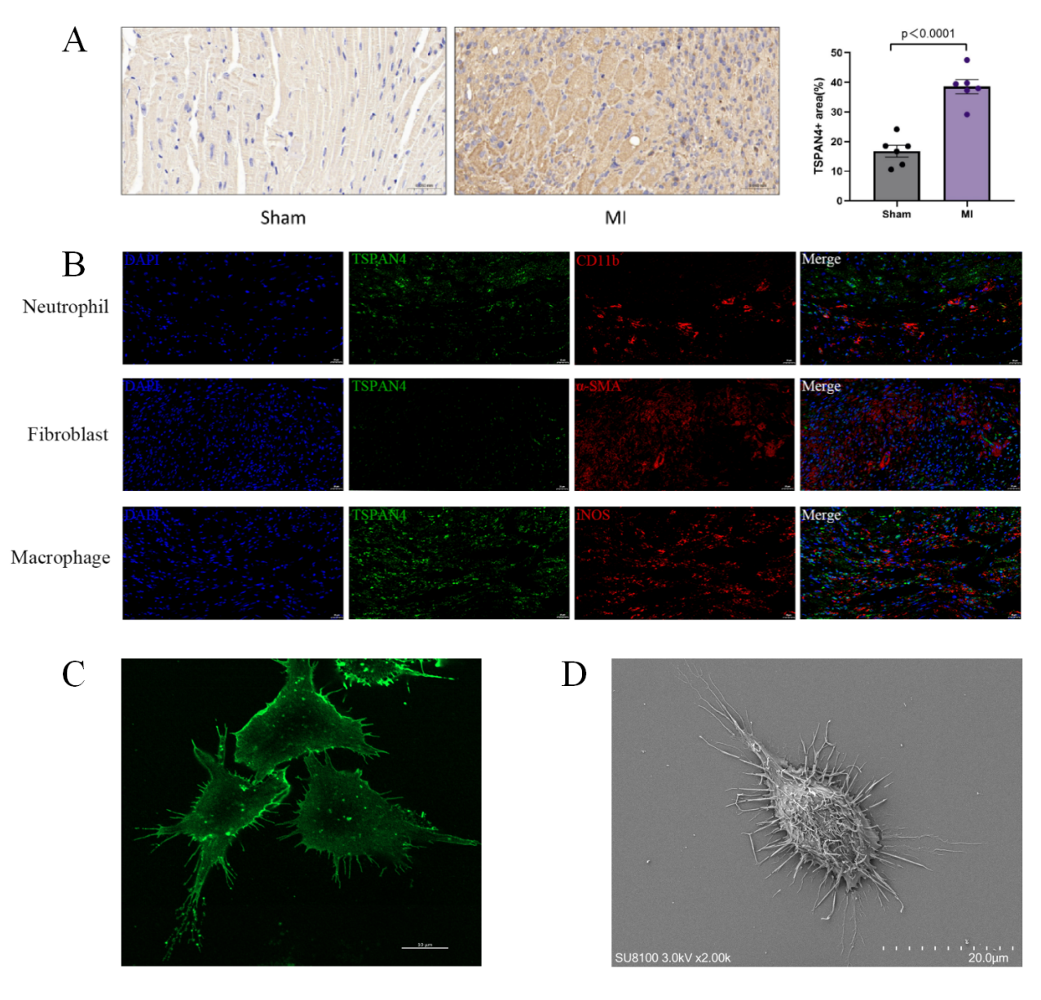
Figure S1. Immunohistochemistry and immunofluorescence analysis of myocardial tissues from MI mouse models. A) Representative immunohistochemistry (IHC) images (left) and quantitative analysis (right) of TSPAN4 (a specific marker of migrasomes) in myocardial tissue sections (n = 6). TSPAN4 expression was significantly elevated in the MI group compared to the sham-operated (Sham) group (p < 0.0001). B) Immunofluorescence co-localization analysis of TSPAN4 (green) with cell-type specific markers (red) in myocardial tissues: Neutrophil (CD11b, red), Fibroblast (α-SMA, red), Macrophage (iNOS, red); DAPI (blue) for nuclear staining. Scale bars = 25μm. C) Immunostaining images of wheat germ agglutinin (WGA)-labeled M2 macrophages. Scale bars = 10 μm.(n = 3) D) SEM images of M2 macrophages (n = 3). Scale bars = 20 μm. Results are presented as mean ± SD. **p < 0.01, ***p < 0.001. One-way ANOVA or two-way ANOVA was used for multivariate analysis, and unpaired t-tests for comparisons between two groups.

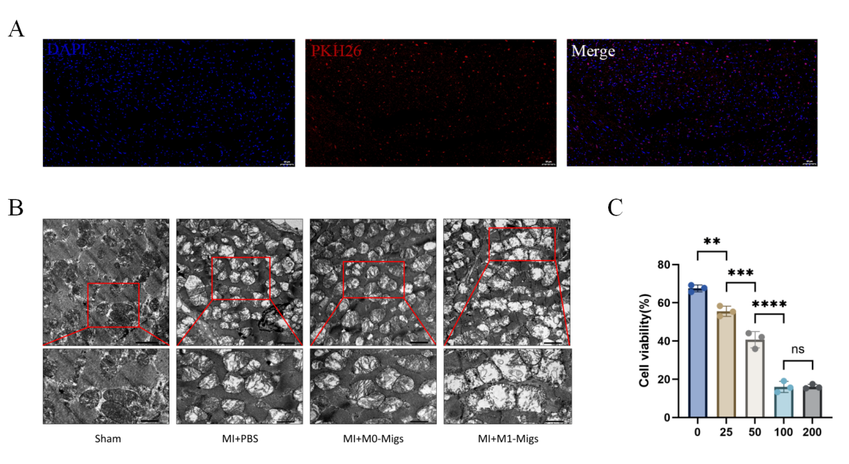Figure S2. Functional validation of M1-Migs at animal and cellular levels. A)Representative fluorescent images of mouse myocardial tissues following intramyocardial delivery of PKH26-labeled migrasomes (red). Migrasome distribution was visualized in myocardial sections, with DAPI (blue) used for nuclear staining; scale bars are indicated in individual panels. Scale bars = 50μm. B) TEM observation of myocardial tissue sections from different treatment groups. Myocardial cells in M1-Migs-treated mouse tissues showed more pronounced swelling and severe mitochondrial damage. Scale bars = 2 μm and 1 μm. (n=6) C) CCK8 assay of cardiomyocytes treated with different concentrations of M1-Migs. Cardiomyocyte viability significantly decreased with increasing M1-Migs concentration. (n=3) Results are presented as mean ± SD. **p < 0.01, ***p < 0.001. One-way ANOVA or two-way ANOVA was used for multivariate analysis, and unpaired t-tests for comparisons between two groups.
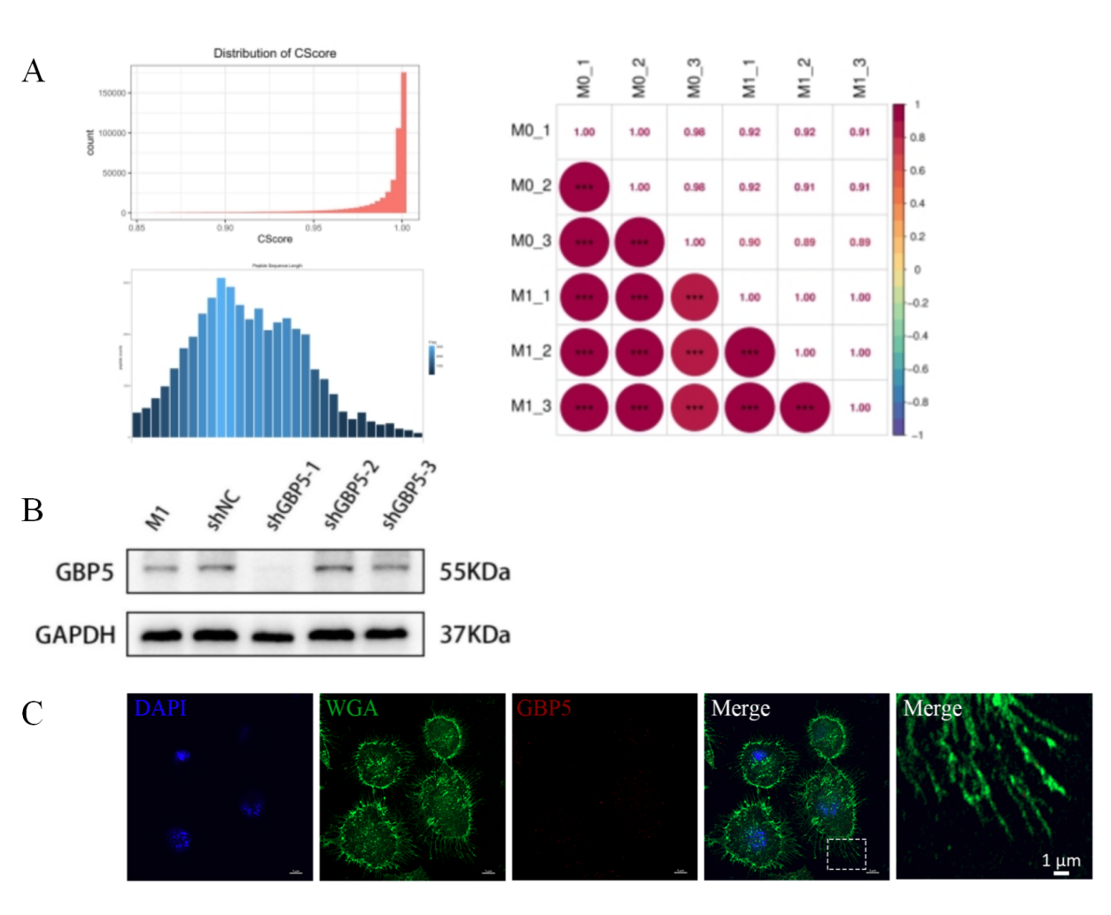
Figure S3. Proteomic sequencing of M1-Migs and M0-Migs was performed. A)Quality control and correlation analysis were conducted for the two groups of samples. B)Lentivirus-carrying shGBP5-1 significantly knocked down GBP5 expression in M1 macrophages, and the cell line was expanded for subsequent experiments. C)Immunofluorescence localization of GBP5 in M0-Migs. Scale bars = 5 μm (low magnification) and 1 μm (high magnification). Three independent biological replicates were performed.
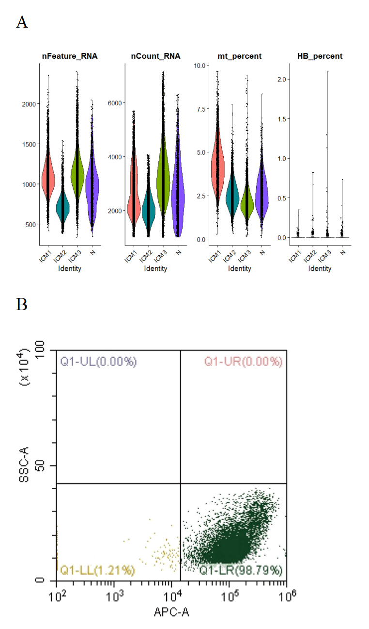
Figure S4. Data analysis of clinical samples. A) Quality control of raw sequencing data. B) Flow cytometry analysis with CD14-APC antibody to verify the purity of peripheral blood monocytes sorted by magnetic beads. Three independent biological replicates.

Figure S5. Colchicine inhibits migration and migrasome biogenesis in M0 macrophages. A) Transwell assay shows colchicine reduces migration of M0 macrophages. Scale bar=100 μm. (n=3) B) Wound healing assay demonstrates decreased migration area of M0 macrophages after colchicine treatment. Scale bar=100 μm. (n=3) C) Immunofluorescent staining with WGA and DAPI confirms colchicine suppresses migrasome formation. Scale bar=5 μm. (n=20) Results are presented as mean ± SD. **p < 0.01, ***p < 0.001. One-way ANOVA or two-way ANOVA was used for multivariate analysis, and unpaired t-tests for comparisons between two groups.

